**Project 6 Progress Report**

Our project will be a park scene, simulating a fountain with its water flowing out and to the bottom of the frame, a rope with a ball swinging back and forth and being compressed below the fountain, and a flock of birds and a bird of prey appearing to dive in and out of the flock of birds.

**Fountain Simulation:** Brandon Kerbow

The BouncyParticle class uses particle simulation by extending the Particle class which we were provided with. An instance of the BouncyParticle class will take as parameters values for the initial position (_x and_y), initial velocity (_vx and _vy), a radius _r, dimensions of the screen (screenWidth and screenHeight), and an elastic coefficient. A bouncy particle behaves exactly like a normal particle except it bounces off of the “walls” created by the edges of the canvas. The elastic coefficient can range from 0.5 to 1 and affects how much height is lost with each bounce, with a value of 1 representing a perfectly elastic collision (i.e. no height lost when bounced). Objects of this type can have forces applied to them and can be displayed. The code for this class has been completed and the UML diagram is shown below.

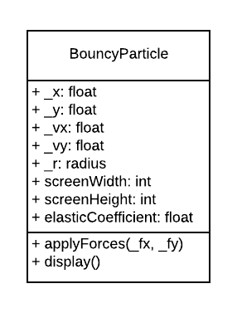

**Birds and Predatory Birds:** Jonathan Kizer

The Birds will represent a rules-based flocking simulation. The regular Bird() objects will be controlled by three rules:

1. They will move in the average direction of all other bird objects,
2. They will move so that they are in the same average position as their neighbors,
3. They will move so that they avoid “crowding” (or occupying the same 2D space)

Additionally, I will attempt to create a predatoryBird() object that functions similarly, but adds another rule to the Bird() object: Bird() objects will move so that they stay away from the predatoryBird().

The anticipated variables and functions are shown below in the UML diagram.



**Pendulum**: Alexis Zhang

The pendulum will be created with two PShapes, a rope and a ball. Without additional operation, the pendulum will swing back and forth with gravity force applied on it. Besides the display method, class pendulum has another method mouseClick, this function is an interactive function. Every time the mouse Clicked, the ball will do a vertical spring simulation along the rope with a dampening force.

